**##TITLE##**

Alampally Naveen

SCOPE, VIT,

Vellore TN, India [alampallynaveen123@gmail.com](mailto:alampallynaveen123@gmail.com)

Boddu Manoj

SCOPE, VIT,

Vellore TN, India

###@gmail.com

Golla Akhila

SCOPE, VIT,

Vellore TN, India

###@gmail.com

**Abstract:**

The COVID’19 pandemic situation keeps on ruining and affecting the wellbeing and prosperity of the worldwide population and due to this situation, the doctors around the world are working restlessly, as the coronavirus is increasing exponentially and the situation for testing has become quite a problematic and with restricted testing units, it’s impossible for every patient to be tested with available facilities. Effective screening of infected patients through chest X-ray images is a critical step in combating COVID-19. With the help of transfer learning, various radiology images are trained in the dataset. The methodology implemented is beneficial to the medical practitioner for the diagnosis of coronavirus infected patients where predictions can be done using machine learning. Using different deep learning algorithms that are used to predict the COVID with the help of chest X-ray image, the outputs of the algorithms are evaluated based on performance metrics such as Accuracy, Precision, Recall, and F1-score. With the help of an X-ray radiology image, the result can be predicted whether the person is having coronaviruses or not. In this work, by using different machine learning algorithms and comparing the accuracy rates of the algorithms and the best fitting machine learning algorithms is taken to predict the COVID-19.

**Keywords:** COVID, X-ray Images, Transfer learning, Radiology, Deep Learning, Diagnosis.

1. **Introduction:**

COVID’19 has influenced many nations in a very little amount of time. The Coronavirus has given a devastating blow to the entire world which is detrimental to the health condition of many people and continues to intimidate the world. This newly identified virus is extremely dangerous and pathogenetically different from SARS-CoV, MERS-CoV, avian influenza, influenza, and other various common respiratory viruses [1]. Although the diagnosis process has become relatively rapid, the financial issues arising from the cost of diagnostic tests affect both the patients as well as the GDP of the country, particularly in countries with private health systems, or restricted access to health systems. So far, due to the lack of availability of public images of COVID-19 patients, detailed studies reporting solutions for automatic detection of COVID-19 from X-ray (or Chest CT) images are not available [2]. In March 2020, there has been an enormous increase in COVID cases which consequently, lead to a rapid increase in the x-ray dataset. This helps us to analyze the medical images and recognize potential trends that help in the automatic diagnosis.

The Automated and Early Covid-19 diagnosis can be helpful for the countries to immediately refer the patient to quarantine, rapid intubation, or severe cases in specialist hospitals, and control the spread of the disease. We can detect the COVID from x-ray images or CT images using image classification with the help of various deep learning techniques [3]. Due to a gradual increase in cases, the testing of COVID has become the most difficult situation and it also takes more time. To overcome this situation, a model is designed, by which the coronavirus can easily be predicted with the most appropriate deep learning techniques which have the highest accuracy. The effectiveness of the deep learning technique proposed is pre-trained fully convolutional neural networks with regard to their expertise in the automatic diagnosis of Covid-19 from thoracic X-rays.

The use of machine learning techniques for automated medical diagnosis has recently gained prominence by being an adjunct method for clinicians. Researchers are increasingly applying the recent advancements of deep learning to the analysis of chest X-ray images to increase performance and relieve the burden of radiologists. Deep learning, allows end-to-end models to be built to achieve promised results using input data without the need for manual extraction of features. The rapid rise of the COVID-19 epidemic has required the need for expertise in this field. The interest in designing automated detection systems based on machine learning techniques has increased. A weakly-supervised classification and localization system proposed for the computer-aided diagnosis of common thoracic diseases developed a 121-layer dense convolutional neural networks [4]. For many image processing applications, such as image analysis, image classification, and image segmentation, deep learning techniques have demonstrated high efficiency. Image classification is achieved through a descriptor extracting the import features from the images, and then these features can be used using classifiers in the classification task. We train four major convolution neural networks that in recent years have achieved promising results in several tasks that include ResNet50, VGG16, InceptionV3, Xception on the dataset, and evaluate their performance for coronaviruses detection. Here, the algorithms are compared for the prediction of occurrence of COVID-19

1. **Literature Survey**

COVID is one of the major causes of death nowadays. Ali Narin, Ceen Kaya, and Ziynet Pamuk have proposed a deep transfer learning technique-based approach for COVID – 19 detection using Chest X-ray images. They have classified the images from the three datasets used for implementation into four classes namely COVID-19, Normal (healthy), viral pneumonia, and bacterial pneumonia. Five pre-trained convolutional neural network models were used in this study – ResNet50, ResNet101, ResNet152, InceptionV3 and Inception-ResNetV2. The performance analysis showed that the ResNet50 convolutional neural network model showed the highest accuracy in all the three datasets [5].

A deep convolutional neural network design for the detection of coronavirus cases in humans from chest X-ray (CXR) images is called COVID-Net with the help of an open-source, available to the general public COVID-19 dataset. Through this method, they gained deeper insights into critical factors that are related to the COVID-19 cases, which helped doctors with an improvement in screening. The obtained model is a successful one as it has a success ratio of 95.9% in detecting COVID-19 virus and it can also identify non-COVID accurately from a person's chest X-ray. But also, a slight problem would be that the detection decisions are taken only by COVID-Net [6]. They adapted DeTraC (Decompose, Transfer and Compose) – a deep CNN architecture which depends on a class decomposition approach for the classification of COVID-19 images. The experimental results showed that DeTraC had a high accuracy and with a high sensitivity and specificity respectively [7].

The first ever data collection of COVID-19 images are made accessible to researchers. They have collected CXR image data, which is about 542 chest X-ray images from about 262 Covid-19 patients from 26 different countries. Frontal and lateral view imagery have been collected and all the metadata such as when did the patient experience first symptoms and what was his intensive care unit (ICU) status, intubation status or his survival status [8]. Suat Toraman, Talha Burak Alakus and Ibrahim Turkoglu proposed a novel artificial neural network for detecting COVID-19 from the Chest X-ray images and also to classify the dataset images into COVID-19, and pneumonia X-ray images using capsule networks. The results displayed using capsule networks will not only lead to higher accuracy but at the same time can be effectively used for classification in a limited dataset too [9].

The following study attempts to give insights on feasibility of using a deep learning-based decision tree classifier for detecting COVID-19 from chest X-ray images. This proposed classifier consists of three binary decision trees. The first tree classifies the chest X-ray images as normal and abnormal. The second tree identifies the abnormal images with signs of tuberculosis and the third does same thing for COVID-19. The average accuracy achieved by the proposed classifier was found to be 95%. [10]. A deep learning model was used for detecting Coronavirus, which is a sub-branch of artificial intelligence. The dataset used for this research consists mainly of three classes that are coronavirus, pneumonia, and normal X-ray imagery. Fuzzy Color techniques were used to restructure the data classes that would be used as a pre-processing step and the images that were structured with the original images were stacked. In the following step, deep learning models like MobileNetV2, Squeeze Net were used to train the stacked dataset and Social Mimic optimization method was used to process the feature sets obtained by the models. Subsequently, all the features were combined together and categorized using SVM that is Support Vector Machines [11].

In this research paper, the authors used a dataset of X-ray images from patients that have diseases similar to Coronavirus (Covid-19) like pneumonia. Incidents from daily news and cases were utilized for the automatic detection of the Covid-19. The purpose of this study is to evaluate the performance of state-of-the-art convolutional neural network architectures that are suggested over the past years for medical image analysis and classification. Particularly, the method called Transfer Learning was implemented. It is shown in the paper that even for small medical image datasets detection of various abnormalities is an achievable target with the help of transfer learning, and it often yields remarkable results. The outcome of the research proposed that Deep Learning with X-ray imaging may extract quite noteworthy biomarkers related to the Corona virus disease, with the highest accuracy, highest sensitivity, and highest specificity which is quite remarkable [12].

In this paper, the authors developed a deep learning-based lung CT diagnosis system that detects the patients with presence of COVID-19. Here, according to the dataset collected, a deep learning-based CT diagnosis system was created that detects patients with COVID-19. The results of the experiment show that the trained model can identify the COVID-19 patients from others accurately with a high sensitivity and an excellent AUC. In addition, the obtained model is capable of distinguishing the coronavirus patients and pneumonia-infected patients with an astonishing high AUC and recall. Furthermore, the trained model is of great help to assist doctors in diagnosing coronavirus disease since it can also localize the main lesion features, especially the ground glass opacity (GGO). Also, the diagnosis is super-fast. Diagnosis for a patient just takes about 30 seconds. So, the conclusion obtained from this research is that the established models can achieve a rapid and accurate classification of coronavirus, therefore allowing the identification of patients [13].

The authors of this paper compared the Deep learning-based feature extraction frameworks for automatic classification of coronavirus. To achieve the most accurate feature, algorithms such as Xception, VGGNet, ResNet, MobileNet, InceptionV3, InceptionResNetV2, DenseNet and NASNet were used in the accurate classification of the virus. The features were extracted and then fed into several machine learning classifiers to distinguish the subjects as a case of coronavirus or not. The approach used to avoid task-specific data pre-processing methods supports a better generalization ability for unseen data. The performance of the proposed method is collaborated on a freely available dataset of chest X-ray and CT images of coronavirus patients. The best performance was achieved by the DenseNet121 feature extractor with Bagging tree classifier which was a classification accuracy [14].

In this report , the authors implemented a deep convolutionary neural network architecture for the detection of cases of coronavirus in humans from chest X-ray (CXR) images, called COVID-Net, accessible to the general public dataset of COVID-19 with the aid of an open source. In addition to this, they researched how COVID-Net can use an explanatory capacity approach to make predictions. They gained greater insights into crucial factors linked to the COVID-19 cases through this approach, which allowed doctors to enhance screening. The model obtained is a good one as it has a high success ratio in COVID-19 virus detection and can also reliably distinguish non-COVID from the chest X-ray of a human. But also, a slight problem would be that only covid-net is taking the detection decisions [15]. Mahesh Gour and Sweta Jain, introduced a novel stacked convolutional neural network for the automatic analysis and diagnosis of the COVID-19 from the Chest X-ray images of the dataset. The authors obtain different sub-models from VGG19 and create a new 30 layered CNN model called CovNet30 [16].

1. **Methodology**

Diagnostic imaging modalities, such as chest x ray images are playing an important role in confirming the primary diagnosis from the Polymerize Chain Reaction (PCR) test for COVID-19. For the classification of COVID-19 Chest X-ray images into regular and COVID-19 classes, deep convolutional neural networks (CNN) based on VGG16, ResNet50, InceptionV3, and Xception models are developed in this research. This work contains different stages which includes Dataset collection, Data Preprocessing which includes Image Data Generator, Image Resizing, Labelling the Data, Normalizing the data and then finally the implementation of algorithms. In addition, the transfer learning technique is applied to address inadequate data and training time by using ImageNet data.

**3.1 Dataset Collection:**

The first step included creating a new dataset by combining other datasets from heterogeneous sources. Our dataset consists of chest x-ray images of COVID -19 from heterogeneous online public sources like GitHub, Kaggle, and certain data sources mentioned in multiple research papers. There are sufficient amount of COVID19 chest X-Ray images and Non-COVID-19 chest X-Ray images which will be used for the training of the various models. The training of models will also include data argumentation (image data generator) for increasing the training phase and testing phase dataset size.

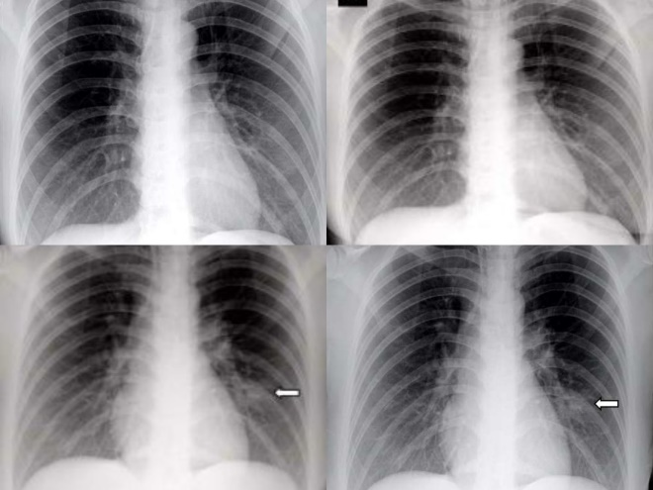

Fig. 3.1.1. X-ray Images of COVID infected patients.

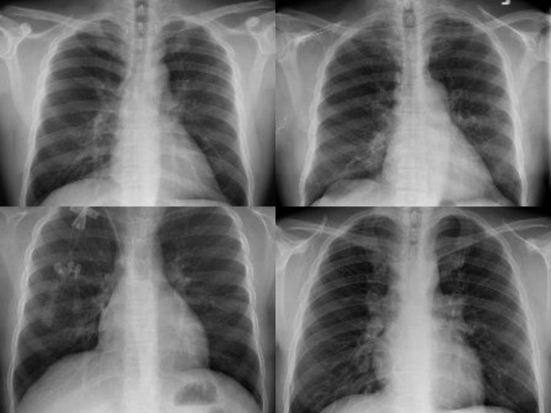

Fig.3.1.2. X-ray Images of Normal patients.

**3.2 Transfer Learning Approach**

Transfer Learning is a research problem in machine learning which is used to store knowledge gained while solving one problem and implementing the known knowledge to solve another related problem. For example, knowledge obtained while learning various types of cars can be used to identify various types of trucks, or one can train an image classification model on ImageNet and can use that learning to initiate tasks - specific learning for detection and prediction on a smaller dataset. Transfer Learning is a very popular concept in deep learning because it can train deep neural networks with short data. In our case, since there is a limited number of data set images for the COVID-19 category, fine-tuning of the last layer of convolution neural networks is only done and pre-trained models are used as a feature extractor. With Transfer Learning, we basically try to use or exploit what is learnt in one task to enhance generalization in other tasks.

* 1. **ImageNet:**

ImageNet is a collection of over 14 million images in a single database or a dataset. The main purpose of designing ImageNet is for advancement in Computer Vision Research. Here all the images present are well organized and are labeled in a hierarchical order. We know that during the training of a Machine Learning or Deep Learning model, a vast dataset of images is a necessity. Our model requires us to learn all the necessary features from the training image. Once trained it learns all features and we can make future predictions and classify images. It is aimed at categorizing and labeling almost 22000 different categories. There are several pre-trained models available on the ImageNet data set.

**3.4** **Architecture:**

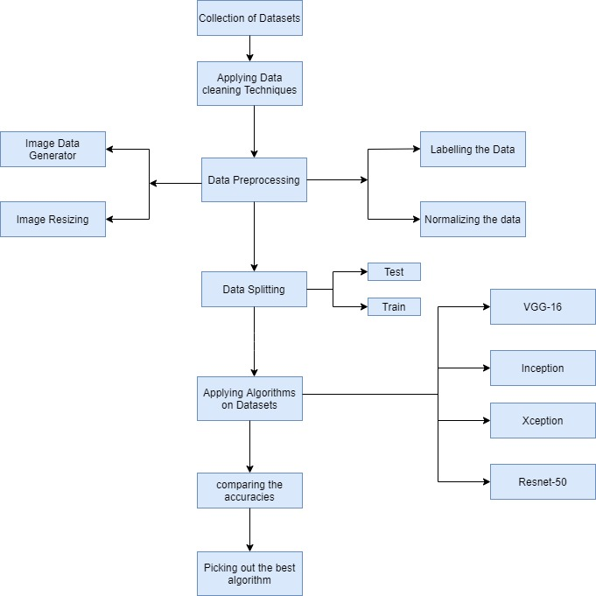

Fig. 3.4.1. Flow chart of the work carried out through the entire process.

* 1. **Dataset Preprocessing:**

As shown in Fig. 3.4.1 Preprocessing of data is the way to establish the same size for all data and to normalize the images in the dataset. Different techniques such as Image Resizing, Image Data Generator, Data Labelling and Data Normalization will be applied to the dataset. With the help of the methods described in Fig. 3.4.1, to enforce the algorithms, we make the dataset eligible to train and evaluate the data. Data Preprocessing is used to make all the data have same size, normalize the image and labelling the data, so we need all the data to be same in size and it will be easy to avoid the unwanted regions and helps in predicting the performance by using it in the algorithm implementation.

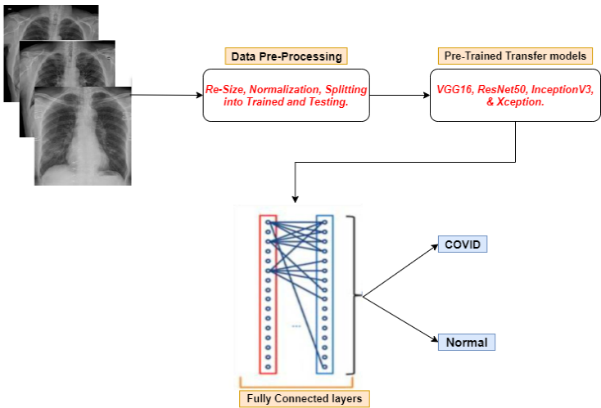

With the help of deep learning, the four algorithms will train the images and then test the dataset with comparative testing images. Before training the dataset, first, the image is resized then labelling the data which will be trained into a separate section or folder and then normalizing the image according to the intensity needed. Then we go for the image data generator to train the model of different versions of the images like changing it to different orientations, angles, rotations, or sometimes images may be flipped, etc. The model is trained for 500 epochs with a batch each consisting of 32 images. Then, the data is split into an 80:20 ratio for training and testing the dataset to predict the outcome of the chest x-ray image.

**3.6 Algorithms:**

Feature Extraction and Classification are type of algorithms which are used to predict the data from images with the help of convolutional neural networks. In this model, Deep learning techniques like VGG16, Resnet50, InceptionV3 and Xception have been chosen for the implementation. In this work, the implementation of all the architectures included the addition of three custom layers in the pre-trained models for training the dataset. The first layer (flatten layer) was used to flatten out the input features. The next layer is the Dropout layer, which buried the problem of overfitting. In order to display the output, a Dense layer which is the final layer along with SoftMax Activation Function was used.

**ResNet50**

Resnet50 is a deep learning pre-trained model, which is trained on ImageNet dataset.The backbone of this architecture involves introducing an identity shortcut connection that will enable us to skip multiple layers. One of the advantages of the said architecture includes helping the network to create a path, which will help us simplify the gradient updates for previous layers.

**VGG16**

The VGG16 technique is deep learning predictive model based on the ability of imitation effects shown by multiple small filters in a sequence with respect to large filters. For interpreting the effect of depth on accuracy a simple CNN with a small convolution filter of size 3x3 with stride and padding of 1 along with a 2x2 max-pool with stride of 2 for 16 layers was used.

**InceptionV3**

InceptionV3 architecture aims to assist in [i](https://en.wikipedia.org/wiki/Image_analysis)mage analysis and object detection. It is a 48-layer deep convolutional neural network. For example, a pre-trained version of the network trained on more than 10 lakh images from the ImageNet database can be loaded. The Inception V3 can classify the images into 1000 object categories, such as man, woman, tree, animals, etc. As a result, the network has learned rich feature representations for a wide range of images. It increases the depth and width of the network and improves the involvement of computing resources inside the network whilst keeping computation operations unchanged.

**Xception:**

Xception is a 71-layer deep convolutional neural network. It involves Depth Wise Separable Convolutions instead of standard Inception modules. It is an extension of the Inception architecture. A pre-trained version of the network trained on more than 10 lakh images from the ImageNet database can be loaded. The Xception model can classify the images into 1000 object categories, such as man, woman, tree, animals, etc. As a result, the network has learned rich feature representations for a wide range of images. In the Xception model first the data goes through the entry flow, then through the middle flow eight times, and finally through the exit flow.

1. **Results**

After Dataset Collection and using various data preprocessing techniques are applied on the dataset. These are some of the results after applying all the algorithms.

**VGG16:**

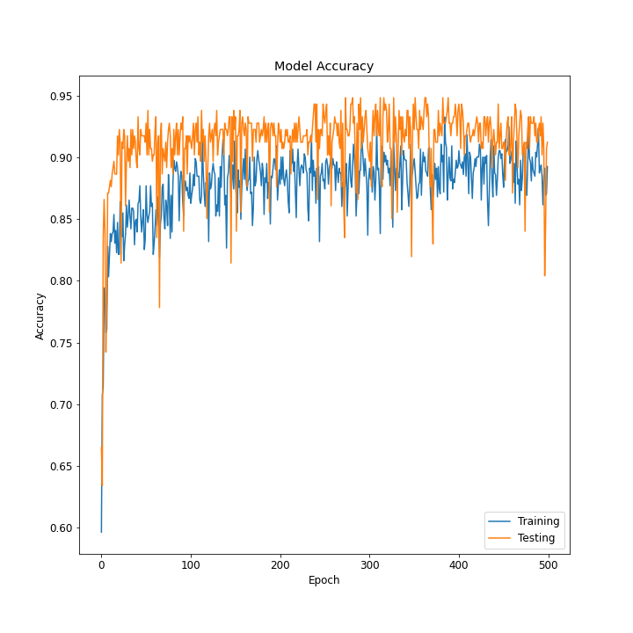

**Fig. 4.1.1.** Epoch Vs Accuracy

In Fig. 4.1.1. In this Model Accuracy, the x-axis indicates the Epoch and y-axis indicates the Accuracy of training and testing of data which displays the graph of our dataset.

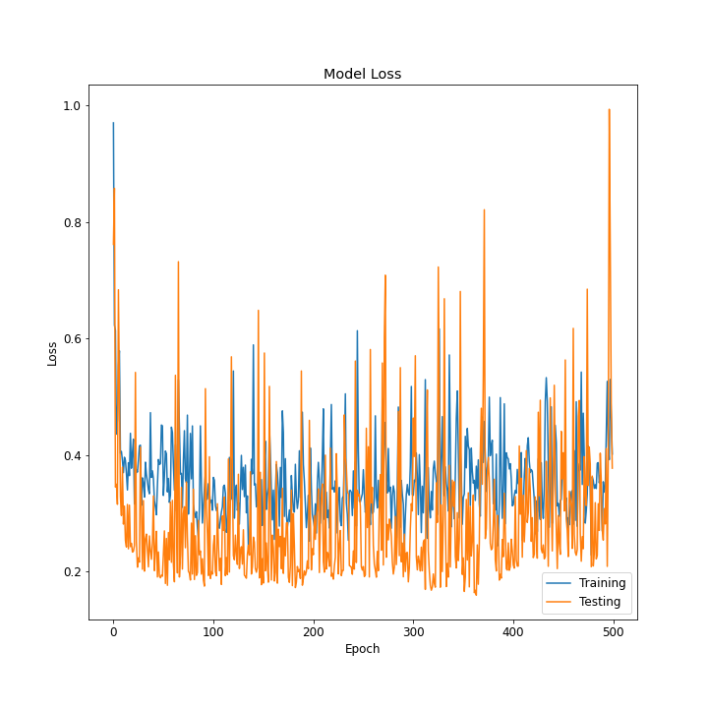

**Fig. 4.1.2.** Epoch Vs Loss

In Fig. 4.1.2. In this Model Loss, the x-axis indicates the Epoch and y-axis indicates the Accuracy of training and testing of data which displays the graph of our dataset.

**ResNet50:**

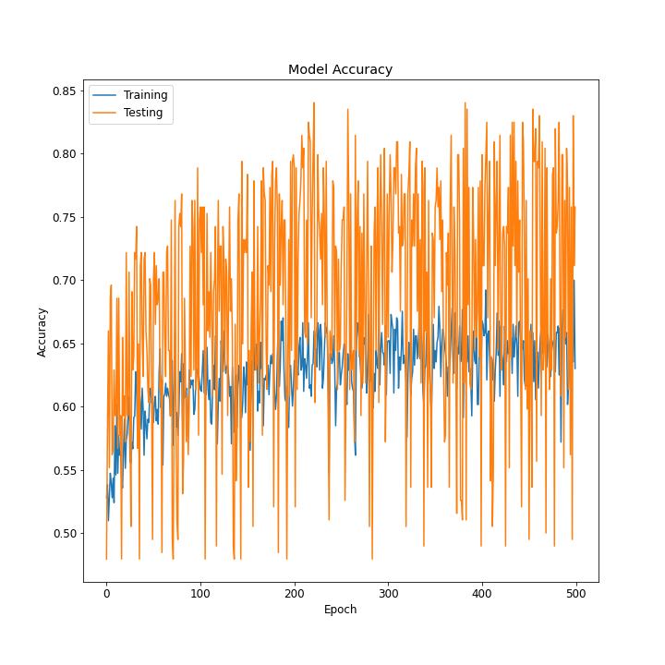

**Fig. 4.2.1.** Epoch Vs Accuracy

In Fig.4.2.1, the graph displays about the model accuracy of Epoch with respect to Accuracy for ResNet50 model.

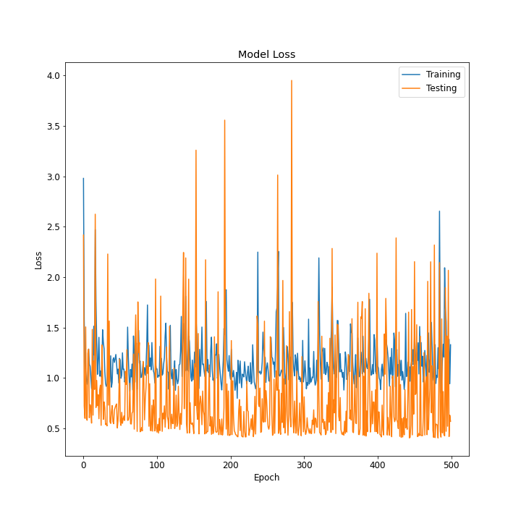

**Fig. 4.2.2.** Epoch Vs Loss

In Fig.4.2.1, the graph displays about the model Loss of Epoch with respect to for ResNet50 model.

**InceptionV3:**

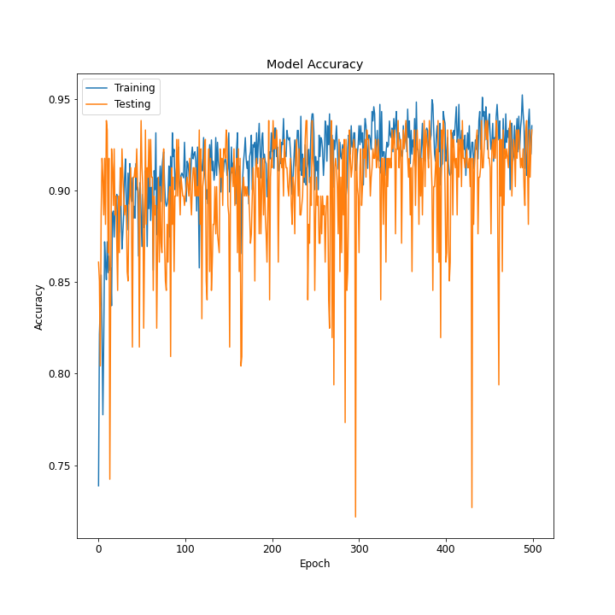

**Fig. 4.3.1.** Epoch Vs Accuracy

In Fig. 4.3.1. In this Model Accuracy, the x-axis indicates the Epoch and y-axis indicates the Accuracy of training and testing of data which displays the graph of our dataset for InceptionV3 model.

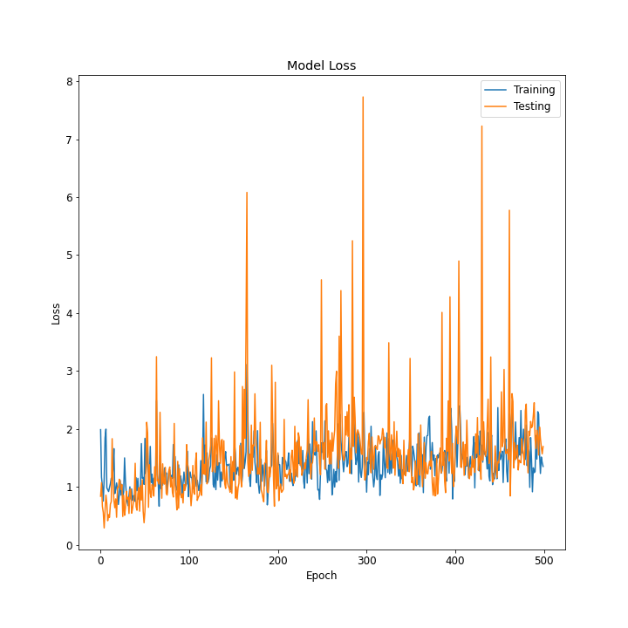

**Fig. 4.3.2.** Epoch Vs Loss

In Fig. 4.3.2. In this Model Loss, the x-axis indicates the Epoch and y-axis indicates the Accuracy of training and testing of data which displays the graph of our dataset for InceptionV3 model.

**Xception:**

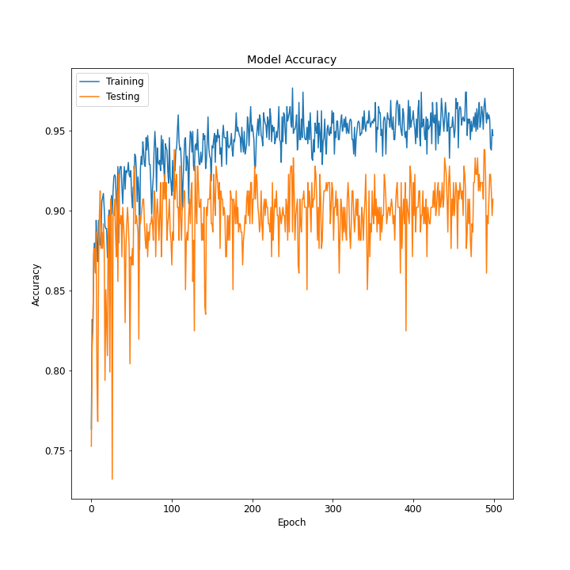

**Fig. 4.4.1.** Epoch Vs Accuracy

In Fig.4.4.1, the graph displays about the model accuracy of Epoch with respect to Accuracy for Xception model.

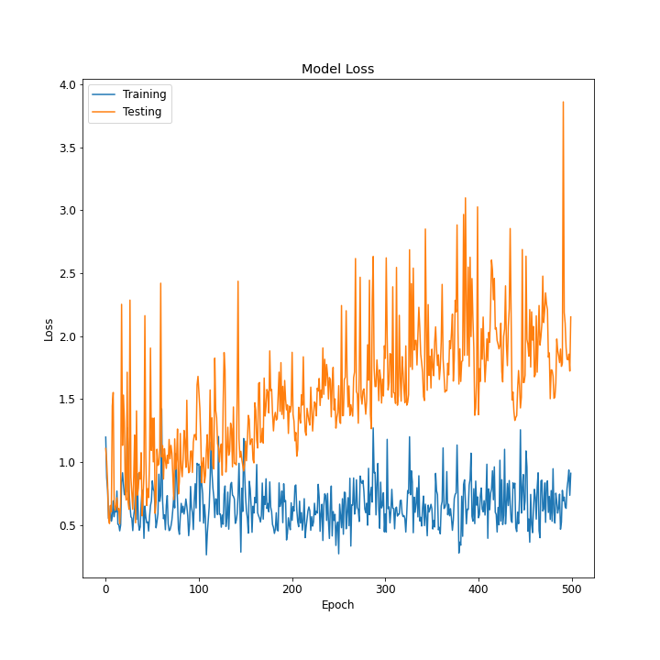

**Fig. 4.4.2.** Epoch Vs Loss

In Fig.4.4.2, the graph displays about the model loss of Epoch with respect to Loss for Xception model.

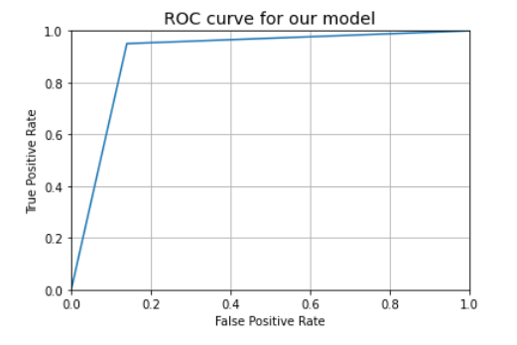

Fig. 4.4.3 False Positive Rate Vs True Positive Rate

In Fig. 4.4.3. In this region of convergence graph, it is a standard measure to check how fast the model is able to classify the data.

|  |  |  |  |
| --- | --- | --- | --- |
| **Algorithms** | **Precision** | **Recall** | **F1-Score** |
| VGG16 |  |  |  |
| ResNet50 |  |  |  |
| InceptionV3 |  |  |  |
| Xception | 0.91 | 0.91 | 0.91 |

1. **Conclusion**

**6 References:**

[1] Wang, L. and Wong, A., 2020. COVID-Net: A Tailored Deep Convolutional Neural Network Design for Detection of COVID-19 Cases from Chest X-Ray Images. *arXiv preprint arXiv:2003.09871*.

[2] Minaee, S., Kafieh, R., Sonka, M., Yazdani, S. and Soufi, G.J., 2020. Deep-covid: Predicting covid-19 from chest x-ray images using deep transfer learning. *arXiv preprint arXiv:2004.09363*.

[3] Cohen, Joseph Paul, Paul Morrison, and Lan Dao. “COVID-19 image data collection.” arXiv preprint arXiv:2003.11597, 2020.

[4] X. Wang, Y. Peng, L. Lu, Z. Lu, M. Bagheri, and R. M. Summers, “Chestx-ray8: Hospital-scale chest x-ray database and benchmarks on weakly-supervised classification and localization of common thorax diseases,” in Proceedings of IEEE Conference on Computer Vision and Pattern Recognition, 2017, pp. 2097–2106.

[5] Narin, A., Kaya, C. and Pamuk, Z., 2020. Automatic detection of coronavirus disease (covid-19) using x-ray images and deep convolutional neural networks. *arXiv preprint arXiv:2003.10849*.

[6] Wang, L. and Wong, A., 2020. COVID-Net: A Tailored Deep Convolutional Neural Network Design for Detection of COVID-19 Cases from Chest X-Ray Images. *arXiv preprint arXiv:2003.09871*.

[7] Abbas, A., Abdelsamea, M.M. and Gaber, M.M., 2020. Classification of COVID-19 in chest X-ray images using DeTraC deep convolutional neural network. *arXiv preprint arXiv:2003.13815*.

[8] Cohen, J.P., Morrison, P., Dao, L., Roth, K., Duong, T.Q. and Ghassemi, M., COVID-19 Image Data Collection: Prospective Predictions Are the Future.

[9] Toraman, S., Alakus, T.B. and Turkoglu, I., 2020. Convolutional capsnet: A novel artificial neural network approach to detect COVID-19 disease from X-ray images using capsule networks. *Chaos, Solitons & Fractals*, *140*, p.110122.

[10] Yoo, S.H., Geng, H., Chiu, T.L., Yu, S.K., Cho, D.C., Heo, J., Choi, M.S., Choi, I.H., Cung Van, C., Nhung, N.V. and Min, B.J., 2020. Deep learning-based decision-tree classifier for COVID-19 diagnosis from chest X-ray imaging. *Frontiers in medicine*, *7*, p.427.

[11] Toğaçar, M., Ergen, B. and Cömert, Z., 2020. COVID-19 detection using deep learning models to exploit Social Mimic Optimization and structured chest X-ray images using fuzzy color and stacking approaches. Computers in Biology and Medicine, p.103805.

[12] Apostolopoulos, I.D. and Mpesiana, T.A., 2020. Covid-19: automatic detection from x-ray images utilizing transfer learning with convolutional neural networks. *Physical and Engineering Sciences in Medicine*, p.1.

[13] Ying, S., Zheng, S., Li, L., Zhang, X., Zhang, X., Huang, Z., Chen, J., Zhao, H., Wang, R., Chong, Y. and Shen, J., Deep learning Enables Accurate Diagnosis of Novel Coronavirus (COVID-19) with CT images.

[14] Kassania, S.H., Kassasnib, P.H., Wesolowskic, M.J., Schneidera, K.A. and Detersa, R., 2020. Automatic Detection of Coronavirus Disease (COVID-19) in X-ray and CT Images: A Machine Learning Based Approach. *arXiv preprint arXiv:2004.10641*.

[15] Wang, L. and Wong, A., 2020. COVID-Net: A Tailored Deep Convolutional Neural Network Design for Detection of COVID-19 Cases from Chest Radiography Images. *arXiv*, pp.arXiv-2003.

[16] Gour, M. and Jain, S., 2020. Stacked Convolutional Neural Network for Diagnosis of COVID-19 Disease from X-ray Images. *arXiv preprint arXiv:2006.13817*.